WAZUH Home Lab - SIEM and File Integrity Monitoring
Matthew Tran
In this home lab I set up Wazuh, a free and open-source SIEM and XDR platform, to monitor a Windows machine from a centrally managed Ubuntu server. The goal was to get hands-on experience with how security events and logs are collected, forwarded, and visualized in a real security operations environment.
The lab walks through installing and configuring the Wazuh Manager on an Ubuntu VM, deploying the Wazuh Agent on a Windows host, connecting the two over a local network, and demonstrating File Integrity Monitoring (FIM), where any file created or deleted inside a monitored folder triggers a real-time alert on the dashboard.

Key Skills:
- Log analysis and aggregation
- File Integrity Monitoring (FIM)
- Intrusion detection
- Vulnerability detection
- Real-time alerting and dashboards
Tools Used
- Wazuh - open-source SIEM/XDR platform (manager, agent, dashboard)
- Ubuntu Server 20.04+ - hosts the Wazuh Manager inside VirtualBox
- VirtualBox - hypervisor used to run the Ubuntu VM
- Windows - host machine running the Wazuh Agent
- ossec.conf - Wazuh agent configuration file for enabling FIM
The key points were:
- Installed and configured the Wazuh Manager on an Ubuntu VirtualBox VM
- Accessed and explored the Wazuh web dashboard
- Installed and registered a Wazuh Agent on a Windows host
- Configured File Integrity Monitoring for a specific directory
- Verified real-time alert forwarding from the agent to the manager dashboard
1. Lab Architecture
Component | Host | Role
Wazuh Manager | Ubuntu (VirtualBox VM) | Collects, analyzes, and stores data from agents. Hosts the web dashboard.
Wazuh Agent | Windows (host machine) | Sends logs, events, and FIM alerts to the Wazuh Manager.
1.1 Same Subnet
WINDOWS
ipconfig
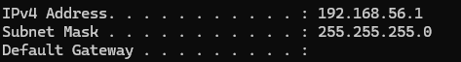
192.168.56.1
UBUNTU
ifconfig
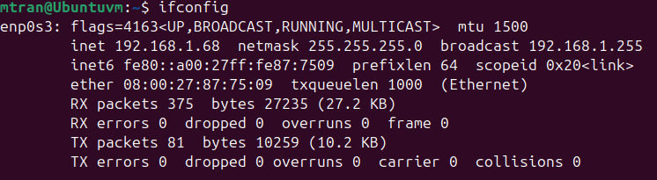

2. Installing the Wazuh Manager (Ubuntu)
I Ran all of the following commands on the Ubuntu VM terminal.

2.1 Add the Wazuh GPG Key
This verifies the authenticity of Wazuh packages before installing them:
curl -s https://packages.wazuh.com/key/GPG-KEY-WAZUH | sudo gpg --dearmor -o /usr/share/keyrings/wazuh-archive-keyring.gpg

2.2 Download and Run the Installation Script
This single command downloads and runs the all-in-one installer, setting up the manager, indexer, dashboard, and Filebeat automatically:
curl -sO https://packages.wazuh.com/4.12/wazuh-install.sh && sudo bash ./wazuh-install.sh -a -i
The installation took around 7 minutes. When it finished, the terminal displayed the dashboard URL, username, and auto-generated password. saved all information.

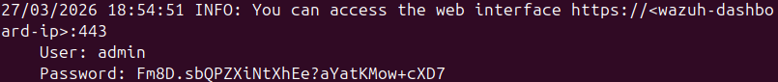
User: admin
Password: Fm8D.sbQPZXiNtXhEe?aYatKMow+cXD7

3. Accessing the Wazuh Dashboard
Once installation was complete, I brought back the Ubuntu VM's IP address:
192.168.1.68 and pasted it in Firefox.
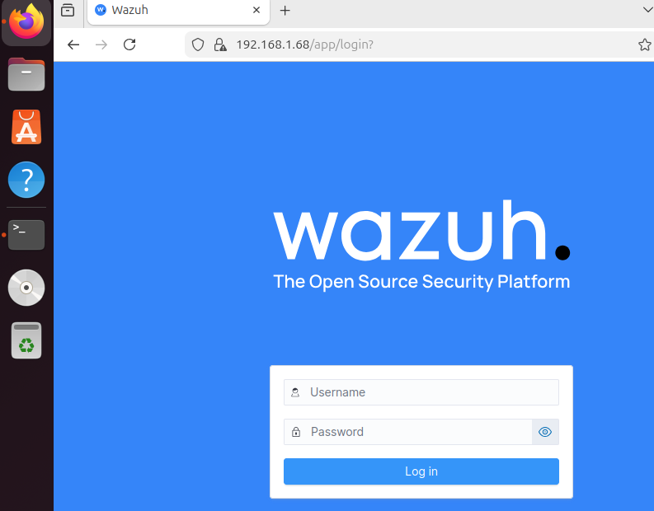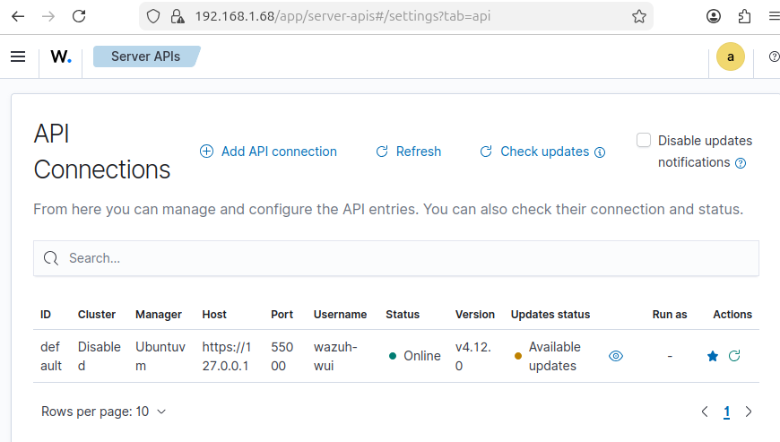

4. Installing the Wazuh Agent (Windows Host)
- Downloaded the latest Wazuh Agent MSI installer from the official Wazuh documentation page for Windows.
https://documentation.wazuh.com/current/installation-guide/wazuh-agent/wazuh-agent-package-windows.html
- Ran the MSI installer using default settings.
- When the installation was completed, I opened the Wazuh Agent Manager from the Start Menu.
- In the Manager IP Address field, I entered the IP address of the Ubuntu VM.
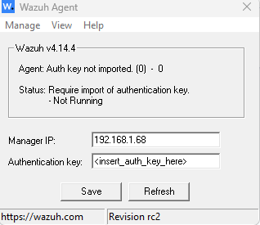

5. Registering the Agent with the Manager

5.1 Generate the Agent Key on the Ubuntu Manager
On the Ubuntu VM, run the agent management utility
sudo /var/ossec/bin/manage_agents

Follow the interactive menu:
- Select A to add a new agent
- Assign a name, WAgent
- Enter the Windows machine's IP address - 192.168.56.1
- Confirm to create, it will be assigned an ID
- Select E to extract the key, then enter the agent ID
- Copy the full key string that is displayed
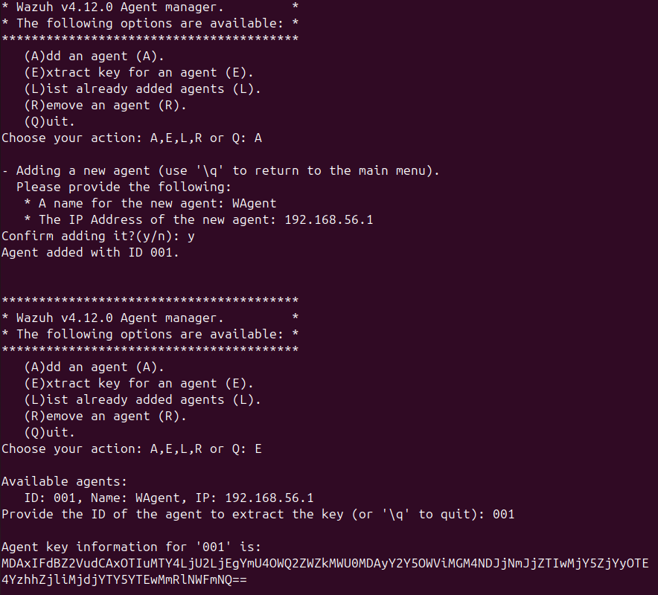
MDA1IFdBZ2VudCAxOTIuMTY4LjEuMjEyIGIwM2MyN2MxZjU4NWUzNDliZmJmYzgxZDU3OGQ3ODgwMzVkYmExYmZiM2Q1NDFjMjVlMGIxOGU3YzU4OGZlNGQ=

5.2 Apply the Key on the Windows Agent
- Open the Wazuh Agent Manager GUI on Windows.
- Paste the copied key into the Authentication Key field.
- Save and apply the key.
- Go to Manage > Restart to restart the agent service.

Go back to the Wazuh dashboard. The Agent Summary should now show one active agent. Click it to confirm your Windows machine is listed with its OS and IP details.
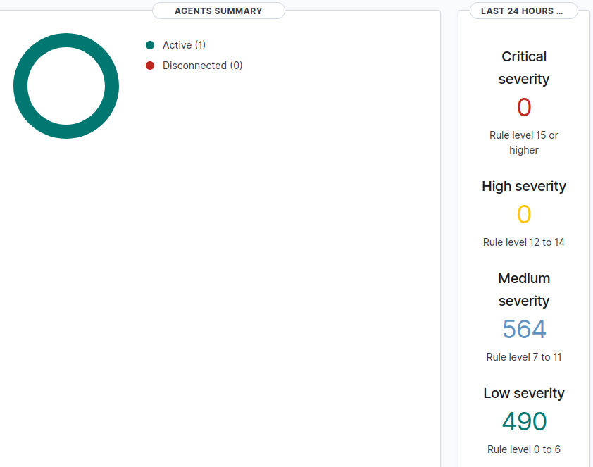
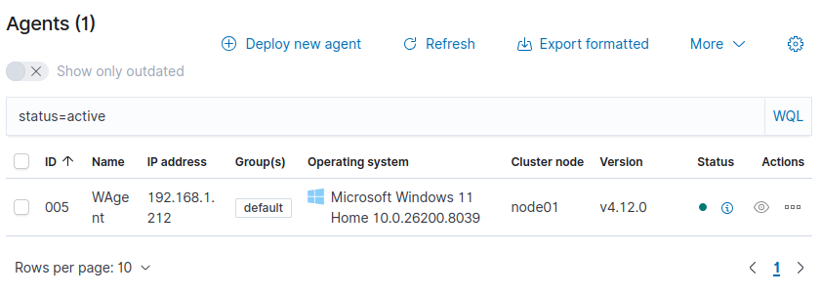

6. File Integrity Monitoring (FIM)
Wazuh's Syscheck module monitors a directory in real time. Any file created, modified, or deleted inside the folder sends an alert to the Wazuh Manager dashboard.

6.1 Creating a Test Folder on Windows
Create a new folder on the Windows machine to use as the monitored directory:
C:\Users\Matth\Wazuh

6.2 Editing the Agent Configuration File
Open Notepad as Administrator, then open the following file:
C:\Program Files (x86)\ossec-agent\ossec.conf
Find the File Integrity Monitoring (syscheck) section. Inside the directories block, add a new line pointing to your test folder:
<directories realtime="yes">C:\Users\YourName\WazuhTest</directories>
Save the file with Ctrl+S.

6.3 Restart the Agent
Restart the Wazuh agent service to apply the configuration change: Manage > Restart in the Wazuh Agent Manager GUI.

7. Verifying the Setup
7.1 Open the Wazuh Dashboard and go to the Windows agent's Integrity Monitoring section.
7.2 On Windows, create a new text file inside the monitored folder
7.3 Refresh the dashboard, a file creation alert appeared with the filename and agent details.
7.4 Delete the file, then refresh again, a file deletion alert appeared.

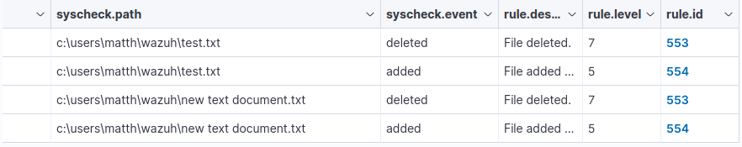

8. Summary.1
This lab demonstrated a complete Wazuh SIEM deployment from scratch, covering potential SOC work. The key points were:
- Installed and configured the Wazuh Manager on an Ubuntu VirtualBox VM
- Accessed and explored the Wazuh web dashboard
- Installed and registered a Wazuh Agent on a Windows host
- Configured File Integrity Monitoring for a specific directory
- Verified real-time alert forwarding from the agent to the manager dashboard

9. Simulated Attack Detection with MITRE ATT&CK Mapping
To extend the lab beyond basic monitoring, I added a Kali Linux attacker machine to my VirtualBox environment, simulated real adversary techniques against the Windows host, and verified that Wazuh detected and categorized them using MITRE ATT&CK framework identifiers. This section documents each step I took, including the exact commands I ran and what I observed in the dashboard.

9.1 Updated Lab Architecture
With the Kali VM added, my lab now consists of three machines on the same Host-Only network:

Component | Host | Role
Wazuh Manager | Ubuntu (VirtualBox VM) | SIEM - collects and analyzes all alerts
Wazuh Agent | Windows (host machine) | Forwards logs and events to the manager
Attacker Machine | Kali Linux (VirtualBox VM) | Used to simulate adversary techniques

9.2 Setting Up the Kali Linux VM
After booting into Kali, I opened a terminal and ran the following command to find the Kali VM's IP address and confirm it was on the same subnet as my other machines:
ip a
The output showed a 192.168.x.x address on the Host-Only adapter, confirming Kali was on the same network as the Ubuntu Wazuh Manager and the Windows host.

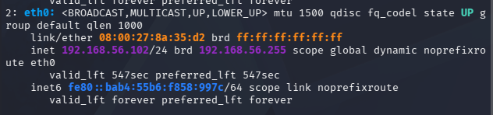

9.3 Enabling Windows Login Auditing
Before running any attack, I needed to make sure Windows was writing login events to the Security event log. By default, Windows does not always log failed login attempts, so I enabled audit policy manually.

On the Windows machine, I opened the Start Menu and searched for my command prompt and opened it with administrator. Inside the policy editor, I entered the following commands
auditpol /set /subcategory:"Logon" /success:enable /failure:enable
auditpol /set /subcategory:"Account Logon" /success:enable /failure:enable
and to make sure it was what I wanted I used auditpol /get /category:* to verify
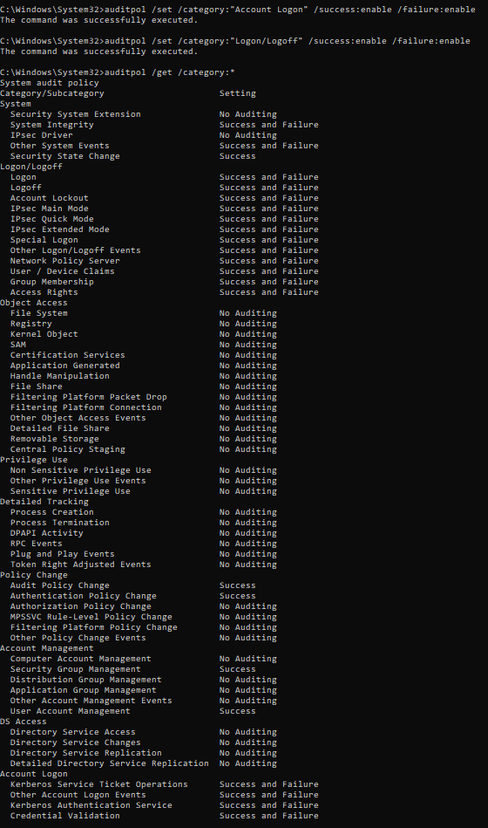
9.4 Running the Brute Force Attack from Kali
With auditing enabled on Windows, I switched to the Kali VM and opened a terminal. I used Hydra, a credential brute force tool that is pre-installed on Kali, to simulate a password attack against the Windows machine over SMB (Server Message Block), which is the protocol Windows uses for file and authentication sharing on a network.
I first make sure the rockyou wordlist is unzipped. On Kali it sometimes comes compressed.
gunzip /usr/share/wordlists/rockyou.txt.gz
I ran the following command, replacing the IP address at the end with the actual IP of my Windows host:
hydra -l administrator -P /usr/share/wordlists/rockyou.txt 192.168.56.1 smb
This command told Hydra to target the administrator account and cycle through the rockyou.txt wordlist, which is a large list of commonly used passwords included with Kali. Hydra began attempting each password one by one against the Windows SMB login.

I let the attack run for about 45 seconds to generate enough failed login events in the Windows Security log, then stopped it with Ctrl+C. The attack did not need to succeed. The goal was purely to generate the failed authentication events that Wazuh would detect.
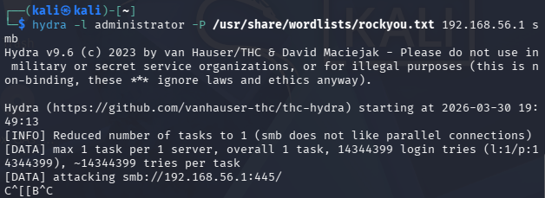

9.5 Verifying the Alerts in Wazuh
After stopping Hydra, I opened the Wazuh dashboard in Firefox on the Ubuntu VM. I navigated to the threat hunting section. I could immediately see a large spike of alerts in the timeline corresponding to the time I ran Hydra. I also searched for rule.id:60104, which is Wazuh's built-in rule for Windows audit failure.
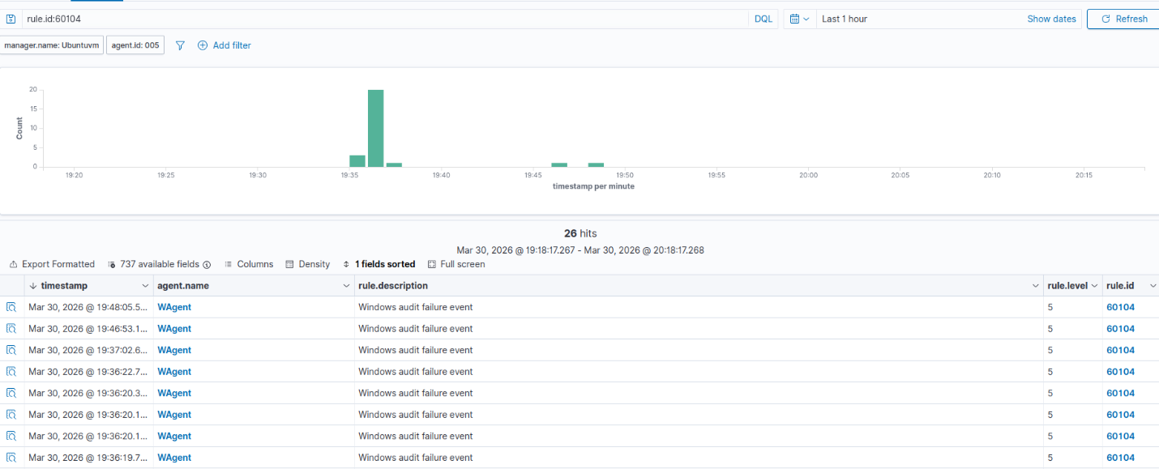
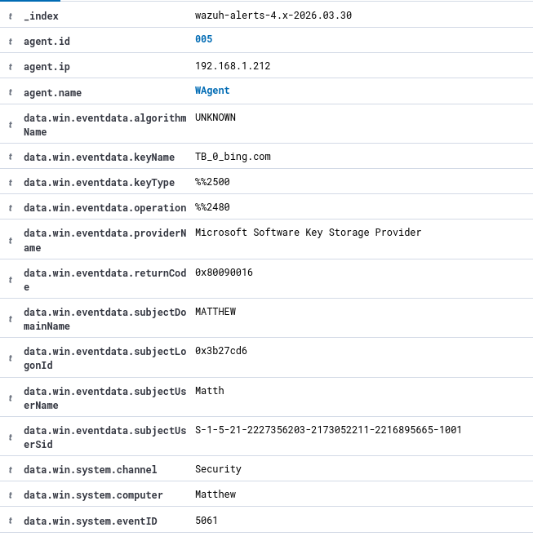

9.6 Simulating Reconnaissance with Nmap
While still on the Kali VM, I also ran a basic port scan against the Windows machine to simulate a reconnaissance technique. I opened a terminal and ran:

nmap -sS 192.168.56.1
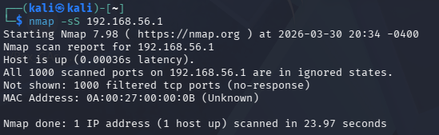
The -sS flag performs a SYN scan, which is a common stealth scanning technique used by attackers to map open ports on a target without completing a full TCP connection. This technique maps to MITRE ATT&CK T1046 - Network Service Discovery.
After the scan was completed, I checked the Wazuh dashboard for corresponding alerts. No alert fired for the port scan. This is a detection gap. Wazuh’s default ruleset detected the brute force authentication failures but did not generate an alert for the network reconnaissance activity.

